An Introduction to Materials: Nature and Properties (Part 1: Structure of Materials)
Prof. Ashish Garg
Department of Material Science and Engineering
Indian Institute of Technology, Kanpur
Lecture – 24
Ionic Solids
Spinel Structure
Other Cubic Structures

So, we start again with the new lecture that is lecture 24. We will again continue about the structure of ionic solids. In the previous lecture, we looked at structures of fluoride structured compounds basically, and fluoride structures compound CaF₂ a structure or A₂X kind of structure where there is a difference in the coordination of cations and anions because of different valances.
So, as a result, your cation is coordinated by eight anions in CaF_{2,} and anion is coordinated by four cations, and converse is true for A₂X kind of compound anti fluorite structured compounds. And the unit cell as we do was a little complicated unit cell, but it is not very difficult I mean, once you draw the top view and one from the top view you draw the 3D view it is it becomes very clear.
So, now we will look at the remaining we started with the spinel structured compounds, which is AB₂O₄. But we look at this in detail, and there are some other cubic structures in which anions are arranged in cubic fashion and anions go to the interstices, they look very similar to FCC in certain cases or BCC in certain cases, but they are not FCC and BCC structure, but they are cubic.
(Refer Slide Time: 01:38)
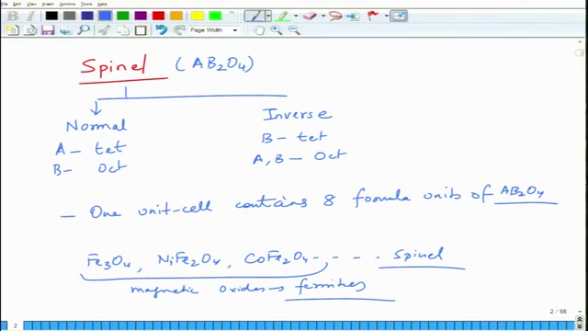
So, let us continue discussing spinel structured materials. So, spinel, as we discussed in the last lecture, there are two variants one is normal, second is inverse. Both are AB₂O₄. In this case, A goes to tetrahedral sites, and B goes to octahedral sites. In this case one of the B goes to tetrahedral sites, and A and remaining B goes to go to octahedral sites. We can see that, in this case, is typically made of 8 formula units.
So, one because to accommodate these interstitial atoms in a regular periodic arrangement, so that you can form a lattice. The lattice does not come in one formula unit. You have to put an eight formula units of AB₂O₄ to put these atoms in interstitial positions in a repeatable manner. So, the lattice is little bigger, that one unit cell contains eight formula units of basically AB₂O₄, it is a bigger unit cell.

